LOCAL ACE LU HANGS ON AT MERCURIES
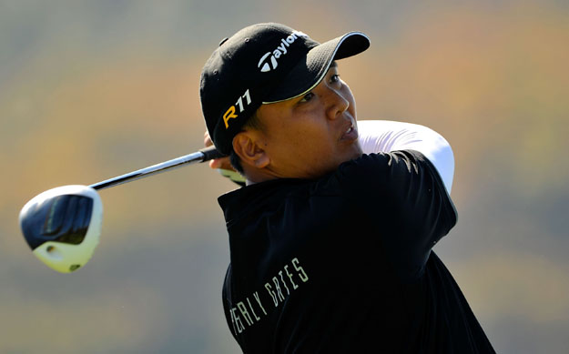
Lu Wei-chih

Taipei, November 5: Local stalwart Lu Wei-chih held on to his lead at the Mercuries Taiwan Masters courtesy of a superb hole-in-one in the third round on Saturday.

Lu holed out on the par three eighth hole with a six iron before adding two bogeys for an even-par 72 on his home course, the Taiwan Golf and Country Club.

Thaworn Wiratchant of Thailand, winner of the event in 2004, battled to a 71 to lie four shots off the pace on 208 in the US$600,000 Asian Tour event.

Teen sensation Miguel Tabuena of the Philippines and Japanese Daisuke Kataoka fired rounds of 72 and 69 respectively to lie a further two shots back on 210 while Chapchai Nirat of Thailand was in fifth place.

Lu failed to emulate his fantastic form in the opening two rounds and admitted he was lucky to cling on to the top spot where he leads on 12-under-par 204.

“Honestly, I felt tired. The sun was really hot yesterday (Friday) and I didn’t feel that well today. I told myself to play it safe and I’m lucky to be leading because of my hole-in-one,” said Lu, who shot his eighth career ace today.

He knows he must overcome the strong challenge from Thaworn to reclaim the Mercuries Taiwan Masters which he won in 2005.

“Thaworn is a good player so there is some pressure going into the final round but I’ll keep a cool head and just play my game. It won’t be easy,” said Lu, a two-time Asian Tour winner.

Thaworn, a former Asian Tour number one, posted two birdies against one bogey to give himself a chance of equalling Thongchai Jaidee’s record of 13 Asian Tour victories.

“I didn’t feel comfortable with my club selections on some holes but I’m still in it with a chance. Lu is playing very well and this is his home course so I still have a lot of work to do,” said Thaworn.

Tabuena, the youngest Asian Tour member at the age of 17, missed a five foot birdie putt on the last hole to trail Lu by six shots. He knows he still has much to play for as a good result will boost his rankings on the Order of Merit where he sits in 108th position.

The top-60 players at the end of the season will earn playing rights on the Asian Tour in 2012.

“My putting let me down. I missed a lot of makeable birdies from five feet but there’s still another day to go and much to play for,” said Tabuena, who is searching for his first professional victory.

Leading third rounds scores
204 - LU Wei-chih (TPE) 66-66-72.
208 - Thaworn WIRATCHANT (THA) 69-68-71.
210 - Daisuke KATAOKA (JPN) 69-72-69, Miguel TABUENA (PHI) 67-71-72.
212 - Chapchai NIRAT (THA) 67-72-73.
213 - Chawalit PLAPHOL (THA) 72-69-72, LIN Wen-tang (TPE) 70-70-73.
214 - Juvic PAGUNSAN (PHI) 72-72-70, Miles TUNNICLIFF (ENG) 72-69-73.
215 - Chris RODGERS (ENG) 71-74-70, WANG Ter-chang (TPE) 71-74-70, BAEK Seuk-hyun (KOR) 72-73-70, Ben FOX (USA) 73-72-70, Simon GRIFFITHS (ENG) 71-73-71, LU Wen-teh (TPE) 70-73-72, Thanyakon KHRONGPHA (THA) 71-71-73.
216 - HSU Mong-nan (TPE) 74-73-69, Panuwat MUENLEK (THA) 70-76-70, Zaw MOE (MYN) 69-75-72.
217 - Artemio MURAKAMI (PHI) 76-70-71, TSAI Chi-huang (TPE) 75-71-71, Angelo QUE (PHI) 72-71-74, Kieran PRATT (AUS) 70-68-79.

Ends.

For further information, please contact Doyle De Costa at +6012 699 1976 at the Mercuries Taiwan Masters media centre.

Ends.

About the Asian Tour
As the official sanctioning body for professional golf in Asia, the Asian Tour leads the development of golf across the region, enhancing the careers of its members while maintaining a commitment to the integrity of the game. The Asian Tour, through its membership of the International Federation of PGA Tours, is the only recognised pan-Asian professional golf tour in Asia. This unique feature positions the Asian Tour at the pinnacle of professional golf in Asia; providing its events with Official World Ranking status. Tour Partners include J.Lindeberg (Official Apparel Partner), Ricoh (Official Office Solutions Provider), Inetol Headwear (Official Headwear Supplier), Royal Selangor (Official Trophy Supplier), Singha Beer (Official Beer), Pan Pacific (Official Hotel), BlackBerry (Official Mobile) and Srixon (Official Ball).

05/11/2011 12:00 AM

