EASY DOES IT FOR LU
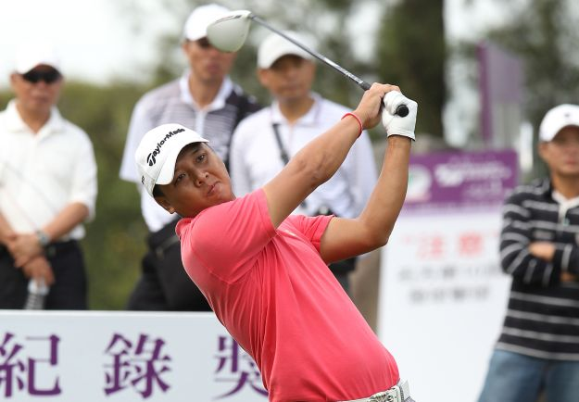
Lu Wei-chih

Taipei, November 3: Local hero Lu Wei-chih put his home course knowledge to good use, firing a solid six-under-par 66 to take the opening round lead at the Mercuries Taiwan Masters on Thursday.

Lu, riding a rich vein of form after winning his second Asian Tour title last month, took a one shot lead over 17-year-old Miguel Tabuena of the Philippines and Thailand’s Chapchai Nirat at the Taiwan Golf and Country Club.

A flu-stricken Zaw Moe of Myanmar, Thaworn Wiratchant, winner of the 2004 Mercuries Taiwan Masters, rising star Panuphol Pittayarat, Japanese Daisuke Kataoka and Park Il-hwan of Korea were a further two shots back on 69 at the US$600,000 Asian Tour event.
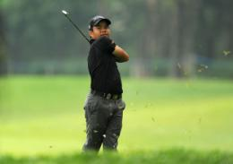
Lu, who stays about a two-minute drive from the Taiwan Golf and Country Club, was not surprised with his superb score highlighted by four birdies in his closing six holes.

“It was an easy round for me. I knew I would have a good score if I can get my putter going on this course,” said Lu, winner of the 2005 Mercuries Taiwan Masters.

“I feel very relaxed here. This is my home course and I played here since I was 13. It is easy for me to relax and calm my mind here,” added the 32-year-old, who sank seven birdies against one bogey.

Tabuena earned his Asian Tour card at the Qualifying School earlier this year as an amateur and joined the play-for-pay ranks in February where he has made three cuts in 10 attempts.

The 2010 Asian Games silver medallist admits he struggled earlier in the season to find his form but is now soaring with confidence after his superb round 67 on a wind-swept day.

“Finally I’m playing some golf! It shows I can compete with the older guys and the best in Asia. My confidence is soaring after my round. I’m hitting shots that I want and I’m confident with my putter again,” smiled Tabuena, the youngest Asian Tour member.

Chapchai, who set the 72-hole scoring record with a stunning 32-under-par 256 total in 2009, said he was lucky to escape with his flawless round where he turned in 32 before adding another birdie on the 15th hole.

“My tee shots were flying left and right the whole day. Sometimes my tee shots would hit a tree and the ball bounced on the fairway. I really escaped with my score and I have to credit my putting which pulled my game,” said the Thai, whose last victory on the Asian Tour was in 2009.

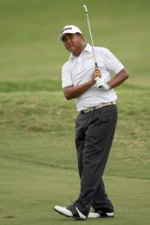
Moe lived up to the adage “beware the sick golfer” as he rose from his sick bed to sink four birdies against one bogey.

“I struggled with flu yesterday but now the fever is coming as well. I’ll take some medicine and rest later,” said Moe, who is in his best form since reverting to a belly putter two months ago.

Leading first round scores
66 - LU Wei-chih (TPE).
67 - Miguel TABUENA (PHI), Chapchai NIRAT (THA).
69 - Zaw MOE (MYN), Thaworn WIRATCHANT (THA), Panuphol PITTAYARAT (THA), Daisuke KATAOKA (JPN), PARK Il-hwan (KOR).
70 - LIN Wen-tang (TPE), LU Wen-teh (TPE), CHAN Shih-chang (TPE), Kieran PRATT (AUS), LIN Chie-hsiang (TPE), Scott HEND (AUS), Panuwat MUENLEK (THA).
71 - SUNG Mao-chang (TPE), Thanyakon KHRONGPHA (THA), Chris RODGERS (ENG), Simon GRIFFITHS (ENG), Martin ROMINGER (SUI), Daisuke MARUYAMA (JPN), WANG Ter-chang (TPE).

For further information, please contact Doyle De Costa at +6012 699 1976 at the Mercuries Taiwan Masters media centre.

Ends.

About the Asian Tour
As the official sanctioning body for professional golf in Asia, the Asian Tour leads the development of golf across the region, enhancing the careers of its members while maintaining a commitment to the integrity of the game. The Asian Tour, through its membership of the International Federation of PGA Tours, is the only recognised pan-Asian professional golf tour in Asia. This unique feature positions the Asian Tour at the pinnacle of professional golf in Asia; providing its events with Official World Ranking status. Tour Partners include J.Lindeberg (Official Apparel Partner), Ricoh (Official Office Solutions Provider), Inetol Headwear (Official Headwear Supplier), Royal Selangor (Official Trophy Supplier), Singha Beer (Official Beer), Pan Pacific (Official Hotel), BlackBerry (Official Mobile) and Srixon (Official Ball).

